Executive Summary

The Bonne Femme Watershed Plan is the product of over 2 ½ years of work from a group of Stakeholders (see Appendix D for committee membership). The Bonne Femme Policy Committee chose to have a broad and balanced representation on the Stakeholder Committee in order to produce a plan that reflects its representation: broad and balanced. The wide variety of perspectives helps to ensure that many points of view are considered in the process, and the balanced nature of the committee improves the likelihood it would not be biased towards a particular special interest group. Local governments will be more likely to adopt the plan if it has support from a wide and balanced range of interests. Although the plan’s focus is on protecting and preserving water quality, the Stakeholders wanted to make sure this was accomplished while maintaining economic vitality and respecting community values.
It should be noted that although the Stakeholders did receive guidance and feedback from the Bonne Femme Steering and Policy Committees, they had the final say on the plan’s content. This ensured it was truly a product of citizen involvement and not one controlled by politicians or technical staff.
The plan is designed to focus local governments on protecting stream health in the Bonne Femme watershed as it urbanizes (see Figure ES.1). It provides policy recommendations that, if adopted, will help to achieve different goals that enhance the Bonne Femme watershed.

Chapter 1 outlines the big picture of the plan. It discusses how the plan relates to the Bonne Femme Watershed Project and how the Stakeholders developed the plan. The watershed’s characteristics (social, physical, and biological) are addressed. Finally, economic activity in the watershed is discussed.

Chapter 2 outlines the issues the Stakeholders wanted to consider during the development of the plan. The issues are listed both in simple form, and in a consolidated grouping that explains how they are connected to one another.

Chapter 3 discusses the scientific information considered by the Stakeholders in the planning process. Parts of this chapter focus on previous, and sometimes general studies, including karst hydrogeology and cave life. Other sections of this chapter discuss work that was completed in relation to the Bonne Femme Watershed Project, including stream life, water quality monitoring, dye tracing, and the Subwatershed Sensitivity Analysis.

Chapter 4 covers the Stakeholder vision for land use in the Bonne Femme watershed, including its purpose and how they developed it. The vision statement is detailed, along with the elements that formed its basis.
Stakeholder vision: In the year 2030, we envision a watershed where quality of life and economic vitality are fostered by maintaining or improving the current conditions of the water resources, having a mix of land uses and development types, and maintaining thriving agricultural activities.

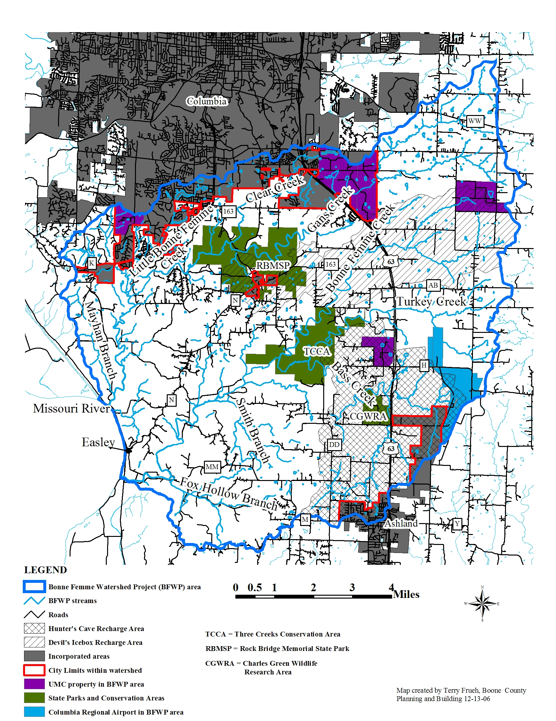
Figure ES.1 Map of the Bonne Femme Watershed Project area.

Chapter 5 discusses how the Stakeholders transformed the vision into achievable goals. The obstacles to achieving these goals are discussed and rated as to their strength (i.e. how much they might impede achieving the goal).

Chapter 6 details how the Stakeholders developed their policy recommendations, lists these recommendations, and discusses how to carry the plan forward.

Plan Recommendations
It should be noted that these recommendations are not in any type of prioritized order.
Recommendations that apply to all goals:
1) It is important to have a follow-up program in order to assess the effectiveness of plan implementation. This follow-up program includes three aspects:
- Enforcement/inspection will assure that new ordinances are being followed.
- Maintenance of new stormwater and sewer infrastructure will be necessary for proper functioning.
- Plan evaluation is key to understanding whether the plan is being followed as intended and how effective the various measures are. This may include actual stream monitoring, as well as analysis of the implementation of the recommendations. Stream monitors must use generally accepted, quantifiable measures of water quality obtained at regular intervals on an ongoing schedule, and the data must be collected by highly certified entities/persons.
2) Equity: Measures implemented to protect water quality should not unfairly burden individuals. Every effort should be made to create incentive-based programs.

Goal | Strategies | Recommendation
Ensure that structures are not built in places that will flood | Update 100 year floodplain maps & regulations | Political subdivisions should consider complete hydrologic modeling to determine where the 100-year floodplain would be under full build-out conditions, and locate it more accurately on floodplain maps. This modeling should be limited to developing areas to keep costs down. Allow no construction of occupyable structures in the re-delineated 100-year floodplain.
 | Zoning –  Streamside Buffer Ordinance | Adopt a stream buffer ordinance that limits construction within its boundaries.
 | Design Manual | Do not permit new development to increase peak flows downstream so that flooding is not exacerbated.
 | Purchase structures that flood now | City or County may offer to purchase a structure, at prevailing market rate, to correct a flooding problem in an existing neighborhood, if the cost of correcting the problem exceeds the value of the structure.

Goal | Strategies | Recommendation
Conserve recharge & karst areas with special protections | Design Manual/ Performance based goals | The level of service (following Columbia’s proposed stormwater manual and ordinance) will be more restrictive than in other areas (e.g. by one or two points on the level of service scale). Local governments will adopt similar, compatible stormwater ordinances and design manuals.
Conserve recharge & karst areas with special protections | Zoning | Zoning ordinances will establish specific criteria for development in karst recharge areas. These should include defining levels of stormwater quantity and quality, and limiting new sanitary sewer to no discharge systems.
Conserve recharge & karst areas with special protections | Land purchase | Local governments may purchase land from willing sellers in karst recharge areas, but other options for protecting water quality should be explored first. Create management plans for this purchased land with a primary goal to protect water quality. (Government takings or eminent domain should not be used for acquiring land for this purpose)
Conserve recharge & karst areas with special protections | TDRs & Conservation easements | Transfer of development rights (TDR) should be established county-wide, with sensitive areas (such as karst recharge areas and steep slopes) being primary sending areas. This program should enable the cities and the County to have joint program reciprocity. TDR and conservation easements should be economically and logistically feasible options for use by landowners and developers.
Conserve recharge & karst areas with special protections | Tax relief | Create incentives to encourage conservation in karst recharge areas.
Conserve recharge & karst areas with special protections |  | Adopt a sensitive area protection ordinance

Goal | Strategies | Recommendation
Ensure that changes in land use do not increase downstream flooding, decrease water quality, or increase channel instability | Design Manual | The level of service (following Columbia’s proposed stormwater ordinance and manual) for stormwater runoff quantity after development shall be no less than predevelopment. Similarly, stormwater quantity should have the same characteristics for post-development as it had pre-development. Local governments should adopt similar, compatible stormwater ordinances and design manuals.
 | Encourage LID style development | Local governments should establish additional zoning and subdivision regulations that allow LID-types of development as a matter of right (i.e. approval will be expedited). This avoids the problems associated with the planned development process and encourages LID.
 | Education | Make new stormwater manuals and ordinances widely available and familiar to the public through a public outreach and education effort.
 | Develop funding mechanisms | New sources of funding should be pursued to assist landowners in implementing stream-protection BMPs. Compile available sources of funding and provide to landowners and developers.
 | Financing of storm water program | Secure sustainable, adequate funding for stormwater programs.

Goal | Strategies | Recommendation
Encourage LID-style developments as a way to maintain or improve water quality | Education | Implement a comprehensive educational program for the general public, landowners, and developers to encourage LID-style development.
 | Design manual | Revise local governments’ development regulations to promote environmentally sensitive design and maintenance.
 | Permits | Require land disturbance and building/development permits to conform to LID in all susceptible subwatersheds (following the Subwatershed Sensitivity Analysis).
 | Tax Relief, Funding, Economic development | Create economic incentives to encourage developers to implement LID.

Goal | Strategies | Recommendation
In order to maintain quality of life, encourage parks, healthy streams, LID-style developments, and municipal services. | Land Purchase, Develop Funding Mechanisms, Economic Incentives | Provide mechanisms and/or incentives in non-LID developments for land to be set aside for parks or green space, especially in conjunction with a stream buffer. Encourage these features in other new, as well as preexisting, neighborhoods

Goal | Strategies | Recommendation
Maintain the economic viability of the community while protecting clean streams | Education | Include information on protecting clean streams in development information distributed by the city and county – web, forms, brochures. Develop a map that shows protected areas and include this in all literature related to development.
 | Design Manual | Local governments should adopt similar, compatible stormwater ordinances and design manuals that have stream protection information and requirements.
 | Zoning | Address zoning of areas where protections are needed.

Goal | Strategies | Recommendation
Enhance healthy streams in parks | Education | Make stream protection a central part of park management. Establish park definitions to include stream protection goals. BMPs should be used on property owned by local governments.

Goal | Strategies |  | Recommendation
Maintain clean water without unnecessarily restricting property rights | Design Manual |  | Give detailed design information to developers and engineers to assist them in controlling runoff quality and quantity from development.
 | Zoning |  | Use voluntary zoning changes to direct density, and therefore higher runoff, to the most appropriate areas.
 | Subdivision and Zoning Regulations |  | Revise local governments’ ordinances and design manuals to enable reductions in impervious surface by allowing flexibility in street width, sidewalks, etc.
 | Education |  | Expand educational newsletters for the public and mail them more frequently,
 | Develop funding mechanisms |  | Secure sustainable public funding for the operation and maintenance of BMPs, especially ones that were initially funded by government agencies.
 | TDR’s and Conservation Easements |  | Encourage landowners to use various economic incentives (e.g. conservation easements and TDR).
Goal | Strategies | Recommendation
Have policies which boost jobs, retail, tax base, and local economics | Zoning | Locate retail, by appropriate zoning, to areas that will allow the most efficient usage of infrastructure and the least hazard of stream pollution.
 | Economic incentives | Consider reduction in fees and other expenses paid by developers of commercial property, in preference to the creation of additional special transportation districts. For locally-owned businesses, give economic incentives to help them implement LID.  Use tax incentives for owners of LID-style commercial/retail structures
 | Zoning | Exempt agricultural land from restrictions and stream buffers to keep maximum economic opportunity available for farmers and related jobs as well as to keep land out of residential and commercial development.

Goal | Strategies | Recommendation
The impacts of upstream urbanization should be mitigated to prevent increased costs to agricultural and other downstream property owners. | Performance based goals/design manual | 1) Determine baseline conditions for the establishment of monitoring programs. These conditions should include stream water quality, amount of stormwater discharge, stream cross-sections.  2) Publicly monitor at specified time periods at specific locations to determine effectiveness of currently implemented plan.
 | Develop funding mechanisms | Ensure that local governments provide adequate funding for their stormwater programs via a stormwater utility fee.
 |  | Use land purchase, TDRs, conservation easements, etc. where applicable to encourage conservation in appropriate areas.

Goal | Strategies | Recommendation
Encourage good roads, municipal services, and retail as complementary goals | zoning | Use voluntary zoning changes to define areas appropriate for varying development density, taking into consideration roads and other infrastructure.  Plan development in sensitive watersheds carefully, noting proposed changes on a map of the watershed, and considering the effect on stream quality.
 | Economic incentives | Encourage various funding mechanisms to improve transportation.

Goal | Strategies | Recommendation
Ensure that BMPs do not unreasonably affect housing affordability. | Education | Publicize information on cost-effective BMPs.
 | Zoning | Amend zoning regulations to allow for increased density in exchange for improved stormwater quality and quantity management.

Goal | Strategies | Recommendation
Ensure that certain areas receive special protections while maintaining the economics of urbanization. | zoning | Zoning regulations will reflect the sensitivity of the watershed/subwatershed. This will allow for economic growth while protecting sensitive subwatersheds.
 | Design manual | Revise local governments’ stormwater design manuals with specific design criteria for sensitive subwatersheds.

