Bonne Femme Watershed Project Cost-Share Program

1. Program Description

1.1 Cost-Share Program Purpose
There are two main purposes to the program: 1) To implement practices which help protect the watershed’s streams; and 2) To demonstrate to other people what these practices are, how they are effective, how to implement them, and what are other benefits of having the practices installed (i.e. economic, aesthetic, etc.).

1.2 Eligibility
Anyone who owns property in the watershed may participate. In general, the funds are intended for private property owners, but public property owners can also be considered.

1.3 Best Management Practices (BMPs) Covered

The following is a list of BMPs that can be covered under the program, and there may be additional ones covered depending on a project’s specific situation. Refer to section 2.3 for more details about criteria used in selecting projects.
The BMPs tend to fall into various categories:

Urban and Residential
Completion of an entire LID/Conservation development
Riparian buffers
Low Impact Development (LID) techniques
- Rain barrels
- Rain gardens
- Micro-detention basins
- Etc.
Pet waste reduction
Stormwater retrofits
Streambank restoration
Constructed wetlands
Alternative onsite sewer systems (demonstration only)
Septic system cleaning and inspection
Emergency toxic release containment

Karst
Cave gates
Sinkhole cleanout and revegetation
Sinkhole fencing

Agricultural
Nutrient management
Riparian buffers
Filter strips
Grassed waterways
Alternative watering systems
Fencing livestock out of streams

1.4 Cost-share funds may not be used to reimburse an applicant for the following:
• Any practices, equipment, or supplies used to fulfill the requirements of any federal, state or local permit, such as a NPDES permit or to meet enforcement or other legal requirements.
• Wetland or other mitigation sites
• Practices not sanctioned by Missouri Department of Natural Resources or a partner agency of MDNR
• Practices not installed in accordance with standards and specifications developed by NRCS, MDNR or other recognized standards, where applicable.
• Sales tax

2. Program Participation

2.1 Application
Before applying for the Bonne Femme Cost-Share Program, interested participants should contact the local NRCS/SWCD/MDC office (all located at tel. 875-5540, ext. 3) to determine if they would cover the practice. This eliminates duplication of services. For more information on what other programs are doing, see section 3. If these other agencies will not cover the practice, then the participant should apply to the Bonne Femme Watershed Project’s Cost-Share Program.
An interested participant may send a completed application (found at the end of this document) to:
Watershed Conservationist, Boone County Government Center, 801 E. Walnut, Room 210, Columbia, MO 65201-7730, tfrueh@boonecountymo.org.

2.2 Funding BMPs
In general, the Bonne Femme Watershed Project will fund 60% of the project, and the landowner matches the remaining 40%. Landowners are encouraged to seek other funding from non-federal sources as this may decrease the total amount they need to match. These sources include MDC, MDNR/Boone County Soil and Water Cons. District, nongovernmental agencies (NGOs), and possibly others. If other agencies are providing match, they will need to sign a Memorandum of Agreement (M.O.A.) with Boone County. However, to participate in the program, participants need to match at least 20% of the total amount. Landowners may count in-kind contributions, such as machinery use, farm-raised seed or mulch, and labor, toward their total required match. The rate credited for landowner labor will follow the general labor rate stated in Custom Rates for Farm Services in Missouri (MU #G302).
Since one of the program’s main objectives is to help implement a conservation development (which can be quite expensive), there is no upper limit of how much money the program will provide for a practice. However, for practices commonly covered by other agencies, their rate schedule for various practices will be followed.
Note that these funds can cover design, construction, and any educational materials related to its being a demonstration site (i.e. a sign or brochure about the BMP).
Cost-share allocation for projects will be based on the original estimated costs. Cost-overruns will be evaluated on a case-by-case basis. For overruns, the most the Bonne Femme Watershed Project will cover will be the same apportionment as contained in the cost-share agreement. When less than $1000 remain as cost-share funds are allocated, those funds will be held to cover any errors and/or omissions.
2.3 Selection of projects
Anyone interested in participating in the program should contact the Project’s Watershed Conservationist. An on-site evaluation by Project staff is necessary to determine eligibility for consideration by the Cost-Share evaluation group.
Project staff (and their partners, as needed) will put together a schedule and cost estimate for installing the Best Management Practices selected. When a participant is satisfied with the recommended practices and their estimated costs, a cost-share agreement will need to be signed. Through the cost-share agreement, the participant agrees to install and maintain the agreed-upon BMPs, and the project agrees to supply financial cost-sharing and any other related aspects of the project. The participant receives the cost-share payment after the terms of the cost-share agreement have been fulfilled.
To evaluate applications, the cost-share committee will use several criteria:
- Higher priority will be given to projects in higher priority areas (see Cost-Share Priority map).
- Cost-effectiveness and educational value of each project.
- Urban/residential (see additional criteria for LID/Conservation Development cost-share) and karst types of BMPs will be given priority over agricultural BMPs. There are two main reasons for this: 1) there are many existing cost-share programs for agricultural producers, and 2) since the watershed is urbanizing, the project focuses more on stream issues related to urbanization rather than those related to agriculture.

2.3.1 Criteria for Conservation or LID Development Cost-Share
Cost-share allocation for a conservation or LID development is a specific milestone for the Bonne Femme Watershed Project. Therefore, it is afforded some extra criteria to determine where the funds should be spent. The following criteria will be considered when allocating funds for a cost-share development:
- Educational value
- Cost-disclosure
- Size
- Visibility & accessibility
- Willingness to participate in the cost-share program
- Financial viability
- Number of different types of practices
- Longevity of practices
- Location within watershed

3. Cost-Share Programs from other agencies

There are many cost-share programs in addition to the Bonne Femme Watershed Project’s. Following is a list of programs to help a landowner figure out which ones they might like to apply for. Please contact each agency for additional information about their programs. For convenience, BMPs are listed that do not necessarily protect streams. It is recommended that people interested in participating in a cost-share program contact local agencies in order to see if they are eligible under their programs.

EQIP-Environmental Quality Incentive Program (USDA/NRCS)
WHIP-Wildlife Habitat Incentive Program (USDA/NRCS)
CRP-Conservation Reserve Program (USDA/FSA)
FLEP-Forest Land Enhancement Program (USDA/USFS)
GRP-Grasslands Reserve Program (USDA/NRCS)
WRP-Wetlands Reserve Program (USDA/NRCS)

Additional Programs that may be of interest to landowners:

QHI-Quail Habitat Initiative (Quail Unlimited & MDC):
- Herbaceous vegetation control
- Establishment of nesting cover
- Disturbance
- Old field, fence row, hedge row renovation
- Other…

MMAWI-Mid-Missouri Agriculture Wetland Initiative (Ducks Unlimited & MDC)

Contact Information:
Information about these programs can be obtained by calling 875-5540, ext.3. The Boone County Soil and Water Conservation District (SWCD), United States Department of Agriculture/Natural Resources Conservation Service (USDA/NRCS), and the Missouri Department of Conservation (MDC) Private Lands Conservationist are all located at this office in the Parkade Center (601 Business Loop 70 W., Ste 250, Columbia, Missouri 65203).
Bonne Femme Watershed Project Cost-Share Application

Name___________________________________________________________
Address_________________________________________________________
Phone____________________ Email_________________________________
Project Location__________________________________________________
Parcel identification # (if known)_____________________________________

Have you first contacted the local NRCS/SWCD/MDC to see if your practices would be covered by them? They can all be reached at 875-5540, ext. 3.

Best Management Practice(s) you want to install, and any details you may have on it (if known)___________________________________________________
________________________________________________________________
________________________________________________________________
________________________________________________________________

How this practice helps protect stream health:____________________________
_________________________________________________________________
_________________________________________________________________
_________________________________________________________________

What is your best estimate for the total cost of proposed project(s)?__________
Are you willing to spend at least 40% of this total cost (in labor, materials and cash)? Y N

Signature_______________________________________ Date______________

Please send the completed application to the Watershed Conservationist at the address below. After your application has been reviewed, you will be contacted to set up a site visit.

Terry Frueh
Watershed Conservationist
Boone County Government Center
801 E. Walnut, Room 210
Columbia, MO 65201-7730
tel. 573-886-4330
fax 573-886-4340
tfrueh@boonecountymo.org
http://www.CaveWatershed.org

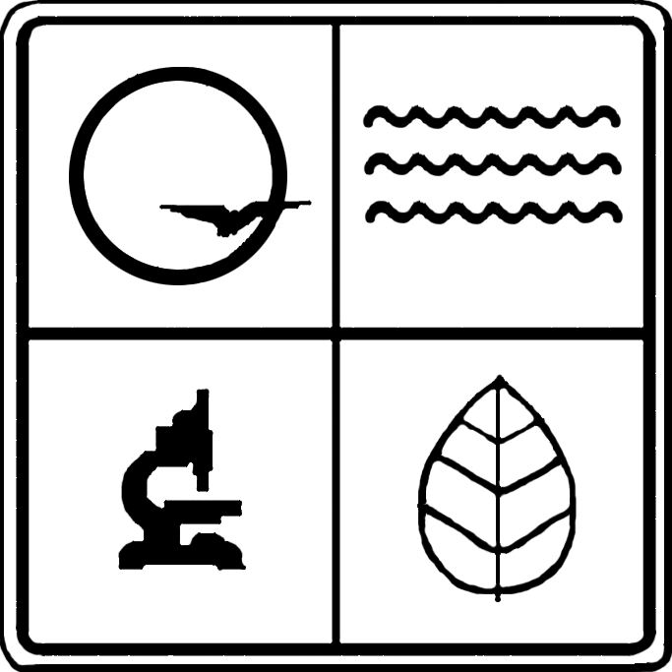U.S. Environmental Protection Agency Region VII, through the Missouri
Department of Natural Resources, has provided partial funding for this
project under Section 319 of the Clean Water Act.

