Chapter 1. Introduction

Italic, bold text indicates words defined in the glossary.

1.a. Introduction to the project

Mission Statement
Use watershed planning as a tool to prevent further degradation and to maintain the long-term quality of water resources within the greater Bonne Femme Watershed.

Bonne Femme Watershed Project Background
Why “greater Bonne Femme Watershed”?
This project includes both the Bonne Femme and Little Bonne Femme Watersheds because they are connected: most of the time, all of the flowing water in the upper portion of Bonne Femme Creek flows underground to the Little Bonne Femme Creek via the Devil’s Icebox Cave Branch, thus the name ‘greater Bonne Femme Watershed’ (See figure 1). For simplicity, ‘greater’ is dropped from the Project’s name.

In 2001, the Directors of the Missouri Department of Conservation (MDC) and Missouri Department of Natural Resources (MDNR) instructed a group of State and Federal employees to work towards protecting the streams in the greater Bonne Femme Watershed. This group, initially called the Southern Boone County Karst Team, decided one way to accomplish this goal was through a Clean Water Act, section 319 grant. These grants, awarded by the Environmental Protection Agency through MDNR, are designed to help protect streams from nonpoint source (NPS) pollution (see Watersheds and Nonpoint Source Pollution sidebar). The funding for 319 grant projects stipulates that 60% of the funds are federal and 40% comes from state and local match.
Since most of the watershed is in Boone County’s jurisdiction, the Karst Team invited Boone County staff to participate on the Karst team and asked the County Commission to sponsor the grant. In November 2001, the Boone County Commission applied for a 319 grant to be administered by the Planning and Building Inspection Department. The grant was awarded in June, 2003 providing funding for a four-year period. Members of the Karst Team became the project Steering Committee. An Urban Watershed Conservationist was hired in October 2003 as the project staff.
The partners for the project include: Boone County Commission, City of Columbia, City of Ashland, Missouri Department of Conservation, Missouri Department of Natural Resources, University of Missouri-Columbia, United States Department of Agriculture (USDA)-Agricultural Research Service, Boone County Soil and Water Conservation District, Rock Bridge Memorial State Park, Chouteau Grotto, and the Friends of Rock Bridge. They were invited to partner by Boone County because their participation ensures a stronger project and helps increase the chance of this watershed-based land use plan being implemented successfully. Their representation on the committee varies widely, with some partners having active involvement on the Policy Committee, and others being called upon as needed. In the process of their participating, they also help meet the local match for the federal funding.

Project Prehistory
There has been a long history of public interest in the natural features of the watershed. The effort to create a park at Rock Bridge started in the early 1900s, although it had been a semi-public area for over half a century. A similar effort to form Three Creeks Conservation Area started in the late 1980s.
A previous pair of grants and a long-term research project in the watershed, all started in the late 1990s, laid an excellent foundation for the work of this project. They accomplished many outreach objectives to increase awareness about the importance of protecting the streams within the watershed while also providing baseline scientific data to establish pre-urbanization water quality conditions within the watershed. The Bonne Femme Watershed Partnership, had many successes during its life, including: establishing demonstration sites (lawn maintenance, residential BMPs, streambank stabilization, and on-site sewage systems), stream cleanups, newsletters, watershed festivals, news articles, and more.
Working collaboratively with the partnership from July of 1998 to June of 2002 the Boone County Soil and Water Conservation District sponsored the Boone Femme Nonpoint Source Special Land Area Treatment (AgNPS SALT) grant. Over 50 people participated in workshops for producers that have livestock on small grazing acreages throughout the watershed. Fourteen workshops with nearly 400 landowners attending were held to educate and promote conservation practices on grazing and row crop land.
Watersheds and Nonpoint Source Pollution
A watershed is the land area that drains water to a particular stream, river, aquifer, or lake.
Nonpoint source pollution, unlike pollution from industrial and sewage treatment plants, comes from many sources spread across an area. This pollution is transported by rainfall or snowmelt moving over and through the ground. As the runoff moves, it picks up and carries pollutants, finally depositing them into lakes, streams, wetlands, and even our underground sources of drinking water.
Stormwater runoff in urban areas has dramatic changes in the timing and quantity of flow (as compared with pre-development flows), in addition to its transporting contaminants. These changes in flow can significantly erode stream channels, thereby destroying infrastructure, personal property, and aquatic habitat.
In order to protect streams, lakes, wetlands and groundwater from nonpoint source pollution, action must be taken throughout the watershed since the pollution sources are spread across the watershed.
Practices installed on the ground included over 550 acres of practices on grazing land. Landowners installed conservation practices on over 3650 acres of row crop land and 30 acres of riparian corridor were established.
Collectively these projects, field days and workshops heightened community awareness of water quality issues and prepared the way for the current project.

Project Objectives
• Help Boone County, and the cities of Ashland and Columbia adopt procedures and policies that will help protect the streams in the watershed.
• Developers and builders will be assisted in adopting best management practices (BMPs) that will help protect the streams' integrity within the watershed.
• Provide cost-share assistance for land owners in the watershed to implement practices that will protect and restore the streams.

The Project’s Committees
The overall goal of the project was to use watershed planning to protect the streams within the watershed. However, the project’s initiators realized that science itself was not going to protect the streams; rather, there is a social and political context that must be considered to successfully develop a land-use plan for the watershed. The Project’s committees (Steering, Policy, and Stakeholder) are discussed in the order they were created (see Appendix C for their membership).

Figure 1 Map of Bonne Femme Watershed Project area

Steering Committee
In 2001, the directors of the Missouri Department of Natural Resources, and Missouri Department of Conservation, appointed a group of people to address protecting the streams in the area. This group, the

Southern Boone County Karst Team , decided to pursue a Clean Water Act, section 319 grant in order to protect the streams from nonpoint source pollution. After being awarded the grant, the Team became the Project’s Steering Committee. The committee includes representation from Boone County Planning, Missouri Department of Natural Resources, Missouri Department of Conservation, Rock Bridge Memorial State Park, and USDA-Agricultural Research Service.
The Steering Committee directed the entire workings of the project and its staff. They represented local, state, and federal governmental agencies that provide scientific, technical, and administrative assistance to help coordinate the other two committees’ work. The Steering Committee was responsible for meeting the terms of the grant which included: facilitating the development of the land-use plan, educating the public, promoting the project to the local media, and administering the cost-share funds.

Policy Committee
The Steering Committee realized they needed strong input and support from local political decision-makers. They chose to include decision-making agencies that affect the timing and location of development in the Watershed to serve on the Policy Committee. Each of the agencies was invited to participate, and each one designated their respective representative. The Policy Committee represents the following entities: University of Missouri- Columbia, City of Ashland, Boone County Water District #9, Columbia City Council, Boone County Commission, Boone County Planning and Zoning Commission, Boone County Regional Sewer District, Columbia Planning and Zoning Commission, and Consolidated Public Water Supply District #1.
The Policy Committee played several key functions throughout the life of the project. They promoted the project and acted as liaisons with their agencies. Since the watershed lies in many different jurisdictions, their interagency coordination was important to ensure their efforts were synergistic and not counterproductive. Another purpose of this group was to communicate with each other at their regular meetings regarding actions or planned actions within the greater Bonne Femme Watershed. They also provided input on the watershed plan and related policy and ordinances. Finally, they were key to acquiring broader community support and for legally accepting and implementing the plan.

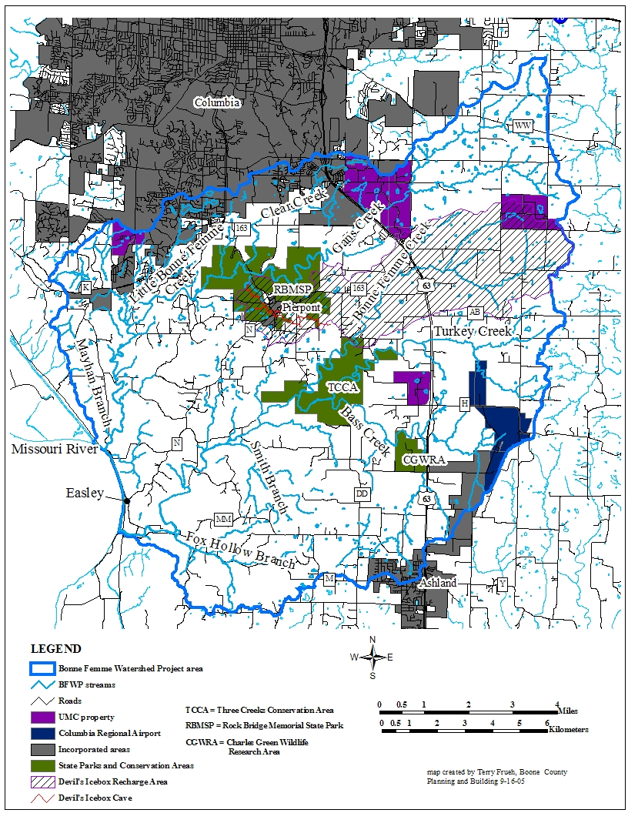
Stakeholder Committee
The Steering Committee realized that the best way to have a successful plan was to include all of the various interests of the community in crafting the plan. These interests were represented on the Stakeholder Committee. The Steering Committee decided the Policy Committee was best suited to appoint the members of the Stakeholder Committee since they best understood who were the best people to represent the various interests necessary to include on that committee.
The Stakeholder Committee gave a balanced, diverse perspective representing community input to the planning process. This breadth of representation on the Committee was essential to making a successful plan the entire community can support. They were also important for making sure the plan gets implemented by garnering community support and speaking at public hearings.

Project Activities

Education
• The Project carried out numerous public relations efforts. A slide-show has been presented to over 10 local groups. The Project’s brochure was distributed to many people and organizations. Annual newsletters were mailed to all landowners in the watershed, and other interested parties. The Project’s web page (www.CaveWatershed.org) was another method used to reach people. An annual open house educated people about the watershed and the Bonne Femme Project. The open house also gave people a chance to voice their opinions about the project. Local media, including newspapers and radio, have both done stories and editorials on the Project.
• The Project has also engaged in several public education events. A driving tour of the watershed in September, 2004 demonstrated the diversity of land uses and landscapes found in the watershed. Over 100 people attended a conservation development workshop in November, 2004 entitled “Development and Conservation: Hand in Hand”. Attendees learned about both the economic and environmental benefits of conservation developments.
Science
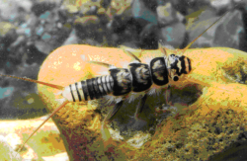
• Water quality grab samples were taken on a quarterly basis at 10 sites throughout the watershed. These sites were chosen to represent the major subwatersheds. The samples were analyzed for concentrations of fecal coliform bacteria, nutrients (total and dissolved nitrogen and phosphorus), herbicides, suspended sediment, and basic physical and chemical parameters (pH, specific conductance, dissolved oxygen, and temperature).
• Dye tracing is a method used to figure out where underground water flows in karst systems. A nontoxic dye is introduced into flowing water, and packets of strategically-placed material that absorb the dye are analyzed to determine if they picked up the dye. If dye is detected we know water flowed from the point of dye injection to the location of the packet. This method was used by state and federal scientists to determine the sources of water to the two major cave systems within the watershed, Hunters Cave and the Devils Icebox.
Figure 3 Stonefly larvae in a stream
• EPT indexing (Ephemeroptera (Mayflies), Plecoptera (Stoneflies), and Trichoptera (Caddisflies), biological Orders of aquatic macroinvertebrates) quantifies the amount and variety of different macroinvertebrates, such as stonefly larvae, present within a stream. These species have a range of sensitivities to pollution. Stream health can be assessed by the quantity and variety of these organisms found within a particular stream.

Subwatershed Sensitivity Analysis (SWSA)
The Bonne Femme Watershed was divided into 19 subwatersheds (see figure X). The purpose of the analysis was to see which subwatersheds are more sensitive to or more easily degraded by development. One part of the analysis used a hydrologic model to simulate how the streams would respond to urbanization. This model looked at how changes in land use would affect the flow in the streams, which has implications for flooding, in-stream habitat, and aquatic species. Another part of the analysis looked at the existing location and quantity of impervious cover to assess current stream health.
Applied Ecological Services, Inc. (AES) was hired in June 2004 to perform the SWSA. They are a broad-based ecological consulting, contracting and restoration firm and have successfully completed projects around the country in this line of work. The company’s mission is to bring the science of ecology to all land use decisions. Their analysis team included cartographers, ecologists, and engineers.

1.b. Stakeholder –led planning methodology

Purpose of Land Use Plan
A stream’s health is most affected by the use of the land in its watershed (see above, box re: Watersheds and nonpoint source pollution). Therefore, in order to maintain the environmental quality of the watershed and its streams, land use and its management in the watershed needs to be addressed. The best way to do this is through creating a land use plan specifically designed to protect streams. A land use plan is a set of policies and guidelines for how land should be used and where growth should occur. Although there are master plans for Boone County and the City of Columbia, they were not designed with stream protection as a specific objective.
This plan is meant to be a living document. It should be revisited on a 5-year basis in order to incorporate new science, technology, and community values.

The Stakeholder story
The process used to develop this plan is not commonly undertaken. Typically, watershed planning is done by a group of technically-trained people, and the community input they get is during public hearings. In another common situation, planning is done by a group of interested citizens who have a particular interest they are trying to protect. In contrast, this plan combines good technical work with strong input from a group representing the broad spectrum of people found throughout the community.
From the on-set of the Project, the Steering Committee felt that strong community input was crucial to the Project’s success. This input would be a clear mandate for local decision-makers to enact the recommendations set forth in the plan. What better way to have community input than to have them develop the plan, thereby ensuring their ownership of the final product? The Steering Committee decided to delegate responsibility for the content of the plan to the Stakeholders. The Stakeholders received help from a technical team (the Steering Committee) to provide scientific and overall guidance. A political team (the Policy Committee) aided them by giving input on what is feasible from a political and legal perspective (see above, Project Committees).
With the framework set up for the Stakeholder Committee, decisions regarding the specifics of who would be invited to serve and the group’s operating procedures needed to be made. The Steering Committee asked the Policy Committee to choose who to invite to serve on the Stakeholder Committee since they knew the most about who best represented the various interests in the watershed. The Policy Committee recognized that more than just landowners needed to be represented since the plan would affect the larger community. They recognized the need to include diverse, even adversarial interests, from those involved in development to those with environmental interests. While the role of development and growth was recognized for its importance to the local economy, the relationship between environmental quality, the economic value of tourism, and quality of life among people living and recreating in the area were all viewed as having significant, if not equal, importance.
The Policy Committee proposed a Stakeholder Committee of 18 people, with three general groups represented: business/construction, environmental, and landowner. With such a makeup, the diverse interests could be well represented, and still have the balance needed to complete a plan palatable to the various groups. The business group would have representatives from construction, development, realtors, engineering, bankers, and business. The environmental group would have representatives from educators, recreators, watershed groups, and environmental groups. The third group would be the landowners, farmers, and homeowners; this group would play the important role of representing those who live in the watershed. It should be noted that interests of the various Stakeholders often over-lapped with those of other groups, and thus it is somewhat artificial to place each Stakeholder in one interest “box”.
The Stakeholders held their first meeting in June of 2004, and continued to work on a monthly basis until completing the plan in ____. Throughout the planning process, the Stakeholders had their own co-chairs who ran the meetings, and they decided how to organize themselves and what voting procedures to follow (see appendix E).

1.c. Watershed Characteristics

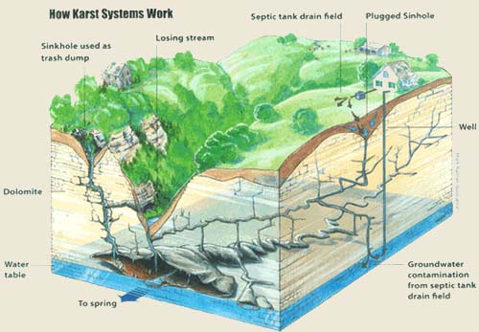
Overview
Figure 4 How karst systems work.
Many people appreciate the special landscapes and streams in the area. This is a diverse watershed, located near a growing urban area in the Midwest: former prairie lands adjacent to steep-sloped karst topography which is next to the Missouri River floodplain. The Bonne Femme Watershed is also special because of its large tracts of high-quality undeveloped lands; some are publicly-accessible, and some are on private land.
The watershed, covering 93 square miles (approximately 15% of Boone County), has many distinctive and beautiful features. Its landscape includes former prairie lands located on clay loess soils, steep-sloped Ozark karst areas (signified by caves, sinkholes, springs, and losing streams), and big river floodplain interspersed with thick silt loess hills. There are five Outstanding State Resource Waters (Devils Icebox Cave Branch, Bass, Turkey, Bonne Femme, and Gans Creeks), and several endangered and endemic species (Pink Planaria, Gray Bats, Indiana Bats, Topeka Shiner, and Cherrystone Snail). Two large tracts of public lands, Rock Bridge Memorial State Park and Three Creeks Conservation Area, provide abundant and diverse recreational opportunities, including caving, hunting, fishing, hiking, picnicking, educational activities horse-back riding, birding, rock-skipping, and more.
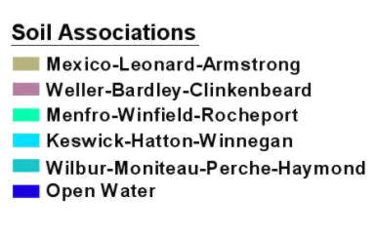
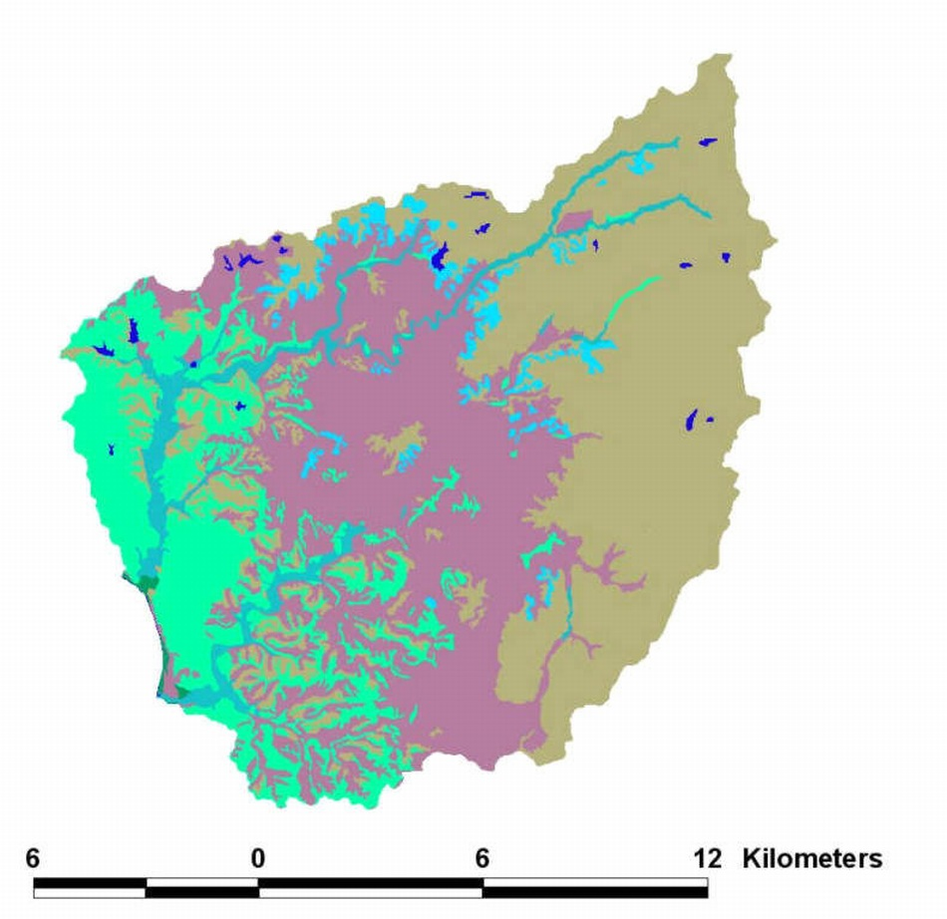
Eastern Prairies (Mexico-Leonard-Armstrong Association)
This area was covered by glaciers, leaving glacial till soils. Then, it was covered by wind blown soils (loess) with high clay content as the glaciers receded. Topography is relatively flat and karst features are absent.
Central Karst Woodland (Weller-Bardley-Clinkenbeard Association)
This area was never covered by glaciers. Soils are mostly the material remaining from weathered limestone bedrock (residuum). Thin loess covers some ridge tops and uplands. This is the karst area in which caves have formed. Topography consists of steep slopes, rock outcrops, sinkholes, and more deeply dissected stream valleys.
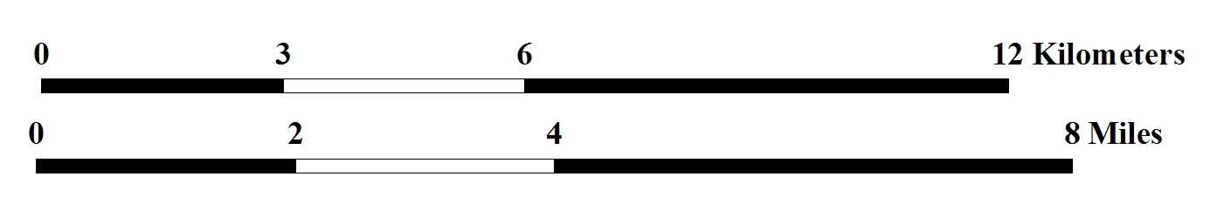
Western Woodlands and Floodplain (Menfro-Winfield-Rocheport Association)
Wind blown (loess) deposits from the Missouri River flood plain. This loess is mainly silt. Steeply sloping hills with few rock outcrops, and no karst features.

Figure 5 Soil Associations

Introduction to Geology, Soils and Ecology by Region:
The Bonne Femme Watershed has three rather distinct natural regions based upon their geology, soils and ecology (Figure 4). The geology and soils of each region are very different. The geology and soils have a profound effect upon ecology. The diversity of the watershed’s natural resources is reflected in the fact that two of the state’s four ecological sections are within this one watershed. According to the Atlas of Missouri Ecoregions (Missouri Department of Conservation, 2002), the Bonne Femme Watershed includes the Claypan Till Plains Subsection of the Central Dissected Till Plains Section (prairie) and two subsections of the Ozark Highlands Section (Outer Ozark Border Subsection and Missouri River Alluvial Plain Subsection). Based upon these distinctions, the watershed has been divided into the following regions: eastern (former-prairie), central (karst woodlands) and western (loess woodlands and river floodplain). The natural features of each region, shaped by the interplay between geology, soils and ecology, are described below.

Eastern Former-Prairie Region:
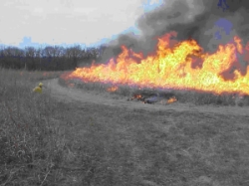
The eastern portion of the watershed, primarily located east of Highway 63, used to be a prairie landscape. It is underlain with the same bedrock described below in the Central Karst Woodlands Region, but in this region, it is covered with several feet of soil. The soil’s origin is not the bedrock. Rather, glaciers deposited most of the soil during the Pleistocene Period that began about one million years ago. The two-mile thick Kansan Glacier entered Missouri from the north and pushed its way into southern Boone County before halting. Soil and rock scraped from lands to the north were left here when the glacier melted. The glacial till soil left behind is between 10 and 20 ft. deep in the Eastern Former-Prairie Region. Fine silty loess soil was blown in from the dry floodplains of the Missouri River to top-off this region with an additional 5 to 10 ft. of loess soil.
Figure 6 prairie burn
The flora and fauna of this region have historically been those of the tallgrass prairie ecosystem. Grasses that once grew there commonly reached heights of about 9 feet tall and sent their fibrous roots down about 12 feet. The grasses and hundreds of species of colorful prairie wildflowers supported an abundance of insects and produced seeds eaten by small mammals and birds. These in turn supported predators such as coyotes, hawks and owls. While very little remains today of this prairie ecosystem, some species dependent upon open grassland habitat still remain in the area, such as the Prairie Warbler and Northern Harrier.
The primary reasons that this region supported tallgrass prairie rather than woodlands were the topography and the common occurrence of fires. Fires hinder the growth of small trees, but don’t harm prairie plants since they normally sprout anew from roots each spring. Fires were set by lightning and by Native Americans. Once lit in dry prairie foliage, the fires traveled until the terrain interrupted their ability to pass. Rivers, moist valleys and rocky bluffs could stop the progress of wild fires. Therefore, the lack of those features, and the relatively flat terrain of the eastern region fostered the passage of fire - fires that favored prairie vegetation.
Over the years, organic matter from prairie plants and animals enriched the already-deep soil of the eastern region. Once John Deere invented a plow that could cut through the tough roots of prairie plants (1837), people were able to begin farming many prairie areas. This region became part of the ‘Great American Bread Basket,’ producing food for a growing nation. Today, only tiny remnants of prairie vegetation exist among the fields of row crops and pastures – making it more accurate to call this the former-prairie region rather than the prairie region. Yet, the deep, rich soils continue to affect the characteristics of the region’s streams. Stream bottoms tend to be mud or sand. Small pools of the upper Bonne Femme have supported prairie fishes, including the endangered Topeka Shiner. This portion of the watershed contains the headwaters where small tributaries in open fields come together to form most of the major streams. All of the watershed’s Outstanding State Resource Waters are partly within the former-prairie region: Turkey, Bass, Bonne Femme, Gans and Devil’s Icebox Cave Branch. While Devil’s Icebox Cave Branch is located in the Central Karst Woodland Region, most of its water comes from a losing section of Bonne Femme Creek that effectively drains the upper Bonne Femme Creek water into the cave. This situation of a soil-rich prairie area feeding water into a cave system is rare in Missouri, and is part of the reason that Devil’s Icebox Cave has more animal life than most caves in the state.

Central Karst Woodland Region:
The Central Karst Woodland region is in the central part of the watershed extending from the north to south boundaries. It’s geologic story starts long ago when much of Missouri was covered periodically by shallow oceans. Sediments and the skeletal remains of organisms living in those waters were deposited and later formed sedimentary rock (about 350 million years ago). This sedimentary rock was raised along with the uplift of the Ozark Mountains (the last of which occurred about 25 million years ago). Since then, erosion shaped the landscape into the rolling hills and valleys that are now known as the Ozarks. Cave openings in the bedrock may have formed before the uplift and been drained by the uplift or formed following the uplift and drained by valleys. In this area, meltwaters from receeding glaciers accelerated the process of cave formation and carried glacial till into caves where openings allowed it to enter. Meltwaters from the glaciers eroded away much of the glacial till soil from the land surface exposing the underlying limestone and its karst features. Meltwater likely is largely responsible for the creation of entrenched meandering streams like Gans, Bonne Femme and Turkey Creeks where the bottoms and bluff walls of the streams are solid bedrock in places.
Two-Mile Prairie
Boone County’s “Two Mile Prairie” was roughly “two miles” wide in an east-west direction and about 25 miles long in a north-south direction. It included almost all of the land in the watershed that is east of Highway 63 and north of Ashland, MO.
Where does the term ‘karst’ come from?
The term karst comes from the geographical name of a region in Slovenia where karst is abundant. It is believed that the origin of this region’s name comes from an Indo-eurpean word, karasattu, referring to people who lived in caves.
In Boone County, the bedrock is primarily Burlington Limestone of the Mississippian System. It is about 100 ft. thick and is visible in bluffs and outcrops, especially along streams where it has been exposed. Burlington Limestone is uniformly crystalline, white to light brown and contains an abundance of crinoid fossils. Because of its abundance, the crinoid is our state fossil. Nodules and layers of gray to white chert (flint) exist within the limestone. Without the chert, the limestone is about 95% calcium carbonate, making it prime material for cave formation. Also known as calcite (CaCO₃), calcium carbonate is soluable when in contact with acidic water. Rain absorbs carbon dioxide (CO₂) from the air as it falls. Then, as it percolates through the soil, it dissolves more CO₂. This chemical reaction between water and carbon dioxide creates carbonic acid (CO₂ + H₂O = H₂CO₃). The crevices and joints of limestone allow water to enter and make contact with the rock. The carbonic acid in the water puts the rock into solution due to the formation of calcium bicarbonate (H₂CO₃ + CaCO₃ = Ca²⁺ + 2HCO³⁻). This dissolved limestone often becomes calcite again when the water reaches cave openings where air reacts to allow the reverse process to occur and separate the calcite, carbon dioxide and water. In the process, calcite deposits (such as stalagtites) of various shapes and colors decorates cave passageways.
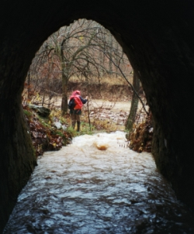
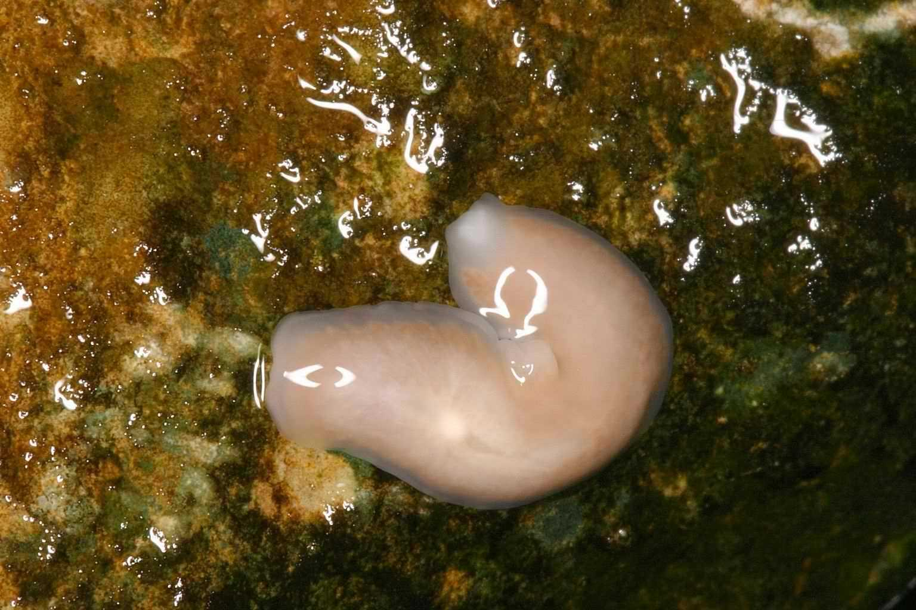
Areas that have types of rock susceptible to being dissolved and that have features such as caves, springs and sinkholes are called karst areas or are said to have karst topography. According to the Missouri Department of Conservation, Boone County ranks as one of the highest cave density counties in the state with 104 caves. The two largest caves and 40 other caves along with numerous springs are located in Rock Bridge Memorial State Park and Three Creeks Conservation Area. Concentrations of sinkholes exist on both of these public lands and on surrounding private lands. The Pierpont Karst Complex is considered a highly developed karst area with hundreds of sinkholes and other karst features. The sinkholes, “losing streams” and cracks in the limestone bedrock allow rain water to flow freely into underground channels, increasing dramatically the potential for contaminants from the land to affect water quality in cave streams and the surface streams they feed into.
Figure 7 looking out from inside Hunter's Cave
The Missouri Department of Conservation’s “Missouri Cave Life Database” currently ranks Devil’s Icebox Cave as 3rd in cave biodiversity for the state with a total of 80 species and eight troglobites. An underground stream carrying an average of about 2.7 M liters/day (709,000 gallons/day) of water travels through 5,990 m (3.7 mi.) of Devil’s Icebox Cave. Known as Devil’s Icebox Cave Branch, this stream supports several species of conservation concern, including the Pink Planarian flatworm (Macrococotyla glandulosa), which is considered to be globally imperiled/vulnerable (ranking of G2G3) due to it's rarity and location within only one cave stream. In addition, the cave has a large white amphipod (Bactrurus brachycaudus) and an isopod (Caecidotea sp.) that was discovered in 2003 and has not yet been described by scientists. Other species of conservation concern that do not live in the stream but do interact in the cave ecosytem include: federally endangered Indiana Bat (Myotis sodalis) and Gray Bat (Myotis grisescens); a troglobitic spider (Porrhomma cavernicola) and Cave Springtail (Tomocerus missus). Except for the bats, these animals are troglobitic (i.e. cannot live outside of caves); they usually lack eyes and have little or no pigment.
Figure 8 Pink Planarian
While uplands may retain some loess soil, most of the central region has soil derived directly from Burlington Limestone. These clay soils were formed from the residuum of weathered limestone. Soil depth varies from a few inches to a few feet. Many hillsides have only a few inches of clayey soil, sometimes interspersed with chert rocks left behind from the dissolved limestone within which it was once enclosed. Alluvial soils, collected along streams, are richer and deeper.
The soils and varied topography of the central region heavily influenced the ecology, which is primarily woodland. Woodlands continue to be prevalent, particularly on hillsides that have not been converted to other land uses. Among the woodlands is a good deal of variety of species because the terrain has a lot of impact on the amount of sun, soil and moisture available to trees. If a hillside faces south or west, the sun’s rays strike it longer, making it dryer and hotter. These are often steep and rocky, making it even more difficult to retain moisture. Some trees such as chinkapin oak and blue ash are tolerant of these conditions. Grasses may vegetate the ground. On the other hand, valleys or hillsides that face the north or east are shaded for portions of the day and tend to have more soil and moisture. These conditions are more favorable for trees such as basswood and walnut and for a variety of woodland wildflowers that bloom in the spring. Rich, moist alluvial soils along streams support yet another collection of trees and plants. In turn, the vegetation affects where wildlife find food and shelter. The factors of soil and topography create varied conditions and result in a mosaic of different terrestrial natural communities within the Central Karst Woodland Region of the watershed.
Interesting karst features of the watershed: Several notable karst features of the watershed include the natural limestone tunnel that gives the Rock Bridge area its name; it is 125 ft. long, 63 ft. high and has an opening about 47 ft. across and 12 ft. high. “Devil’s Icebox” is a karst window that allows entry into the 7th longest cave in the state - Devil’s Icebox Cave with over 6.25 miles of passage. Hunter’s Cave, in Three Creeks Conservation Area is the 34th longest cave in a state of 6,000 caves with 1.58 miles of passage.
These woodland terrestrial natural communities contain a multitude of animals too numerous to list such as woodpeckers, squirrels, raccoons, deer and beavers. Two species of conservation concern that find their habitat in woodlands of the watershed include the Cherrystone Snail and Cerulean Warbler. The presence of over 65 neotropical migrant birds, including several woodland species with high Partners in Flight scores, has caused the National Audubon Society to designate a portion of the watershed as an Important Bird Area.

Western Woodland and Floodplain Region:
The Missouri River Floodplain region is the western and furthest downstream portion of the Bonne Femme Watershed. Most of the water from the watershed in this region is traveling in two large streams – Little Bonne Femme Creek in the northern area, and Bonne Femme Creek in the southern area. Additional small tributaries feed into these streams, the largest of which is Fox Hollow Branch on the south edge of the watershed. This region has a limestone base in similar fashion to the rest of the watershed, but karst features are lacking and the limestone is covered by either alluvium or loess soils.

Insert photo of loess tower here.
There are two distinct areas within this region. The actual floodplain of the Missouri River is nearly flat and has alluvial soils that were eroded from lands upstream and were deposited due to the flooding and meandering of the river. Alluvium is also found along the Little Bonne Femme and Bonne Femme Creeks. The alluvial soils are made up of fine silt and loam and are rich in nutrients. Rich in organic matter and about five feet deep, these soils are among the best in the state for row cropping. Since the Missouri River borders the Bonne Femme Watershed for only about 3 miles and most of the floodplain is on the opposite side of the Missouri River from the watershed, the amount of alluvial floodplain in the watershed is quite limited; the alluvial floodplain along the Little Bonne Femme and Bonne Femme Creeks is also not very wide in most places. The floodplain provides habitat for the federally listed Bald Eagle (in winter), Gray Bat and Indiana Bat (feed above the Missouri River) and Great Plains Toad (limited to floodplains), among others. Pockets of wetlands support plants such as River Bulrush.
Figure 9 Loess tower
While glacial till was not deposited in this region, glaciers still played a significant role in the development of the region’s soils. One of the glaciers, the Wisconsin Glacier, was located many miles from Boone County, but had a profound effect upon the soils of Boone County. Meltwater from the Wisconsin Glacier carried and deposited finely ground rock and silt on the Missouri River floodplain. During the winter seasons when the glacier temporarily stopped melting, the floodplains dried. Then, winds picked up the fine silt and deposited it on the upland areas of Boone County. This material is known as loess. The majority of Boone County loess is of the Peorian type. Most areas of the county were covered to a depth of about 1.5 to 3 m (5 to 10 ft.). However, some areas closer to the Missouri River, have loess deposits up to 30 ft. deep. These loess bluffs often have very steep slopes eroded in deep, narrow ravines.
While loess soil is productive for agricultural use, much of the landscape is too steep for row cropping, thus most of the land is primarily either in pasture or woodlands. The woodlands are pretty similar to those of the Central Karst Woodland Region, except that in many areas the abundant loess soil and the moisture it holds creates a more mesic environment. The Missouri River corridor tends to be an important travel route for wildlife, such as bobcats, that need large tracts of non-fragmented woodlands.
Climate
Boone County has a humid, temperate climate with average annual temperatures from about 54^{O} F to 57 ^{O} F, and ranging from -20 ^{O} to 110 ^{O} F. Long term annual precipitation averages about 39 inches, with the largest amount coming in spring and the lowest in winter. As with temperature, precipitation has a large variation about the average, both on an annual basis, and on a monthly basis. Annual surface runoff averages about 10 inches, with the rest being evapotranspired through plants.

Streams
The streams reflect the diversity of the landscape in the Watershed. In general, at higher elevations (east of Highway 63) they tend to have sandy channel bottoms and silty/sandy banks. As they head southwest, the streams enter areas with deeper valleys and exposed bedrock, and the streams have cobble or bedrock channel bottoms, and cobble mixed in with the soil on the banks. Near the streams’ mouth, they tend to be silty /sandy bottoms and banks.
The streams have a total elevation change of about 300 feet. The largest gradient occurs in the mid-sections (exceeding 60 feet/mile), and the lowest gradient situated in the lowest sections (the Missouri bottoms area). It is the middle section that the streams flow through karst topography. Ample elevation difference combined with the porous limestone has produced springs, losing streams, resurgences and caves in the area. The most notable karst feature is Bonne Femme Creek losing to an underground system. This losing stream results in the upper waters of the Bonne Femme Creek being diverted to cross watersheds and flow through the Devil’s Icebox Cave and emerge into the Little Bonne Femme Creek Watershed. Bass Creek also loses (over a small area), where a meander cutoff allows it to fl
ow through Hunter’s Cave.
Although there are no recording stream gage data available for the creeks in the watershed it is not too hard to describe the nature of the flow. The streams tend to have a low base flow and they rise quickly in response to storms. As with other streams in the Boone County area, the stream flows reflect the drainage surface area and the volume of water introduced through precipitation events, heavily attenuated by evapotranspiration, and further modified by soil moisture and quantity of surface waters prior to and during the precipitation events. The one major exception to this is the losing section of Bonne Femme Creek. The lack of data relating stream flow to precipitation events for these streams means we have no way to determine what changes in stream flow, if any, are occurring due to changes in land use within the watershed.

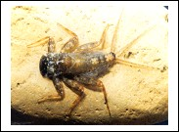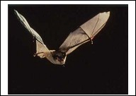

Mayfly larvae (left) that live in streams metamorphose into adult Mayflies (center) that are preyed upon by bats such as the endangered Gray Bat (right) – illustrating the many relationships that connect the fate of various animals to each other.

History
Humans have lived in central Missouri for more than 10,000 years, though not much is known about the first inhabitants of the region. Native Americans likely used the area seasonally for hunting and gathering, with the cool springs being a consistent source of water. Chert was mined for arrowheads and tools.
The earliest Europeans in the area were primarily French fur traders, seeking beaver and other prized pelts to bring back to the fur trading posts of St. Louis. Only a few years after the Lewis and Clark Expedition of 1803-1806, the first settlers began arriving, although hostilities with Native Americans kept immigration to a trickle.
In 1815, when Missouri became a territory, that trickle became a steady stream. A treaty forced out most of the remaining Native Americans. Congress also awarded up to 160 acres in the Boone’s Lick Area to settlers who had lost lands as a result of the New Madrid Earthquake of 1811. Central Missouri also was the destination point for many travelers of the Boone’s Lick trail, which began in St. Louis and continued overland to Arrow Rock in present-day Saline County. These travelers undoubtedly passed through some of the richest and most diverse country some of them had ever seen. The abundant wildlife, the thick oak and hickory forests mixed with some rocky hilltops, native prairie, and plenty of creeks and streams with rich bottomland soil and access to the Missouri River made the Bonne Femme watershed area an ideal location in which to settle.
There were three main types of settlers. Squatters staked claims before U.S. land sales offices opened in Franklin in 1818 and in Columbia in 1825. Subsistence farmers purchased small tracts of land, many of them 80 or 160 acres in size. A third class, the gentry class, were land speculators who bought several hundred acres of land and gradually sold off parcels. The majority of all these early settlers were from the slave-holding states of Kentucky, Virginia and Tennessee, and they brought with them their Southern ideals of “honor, piety and slavery.” Only a few, however, were wealthy enough to own more than a handful of slaves. By 1830, less than ten years after Missouri entered the Union as a slave state, most of the land in the watershed area had been parceled out.
Many of the first settlers lived along wooded creeks and rich bottomlands. While prairies were good for grazing, the general belief was that soil good enough to grow trees was the best for farming, and the wooden farming implements were often not capable of breaking the prairie sod. Also, timber along the creeks provided a ready resource for building log cabins and for heating, cooking and powering mills, distilleries and other economic operations.
Prior to 1830s, most farmers in the watershed area were subsistence farmers, making enough to live on but not much surplus to ship to markets. Common farm crops included Indian corn, maize, wheat, oats, flax and barley. Women tended family gardens which contained peas, beans, sweet potatoes, and Irish potatoes. All the sowing was done by hand. Some tobacco and hemp were produced as cash crops. In the 1830’s, that picture began to change.
Market hunting and habitat loss was beginning to take its toll on wildlife populations. By 1840, furbearers such as beaver and otter were almost extirpated from Missouri; bald eagles, prairie chickens and other species were showing signs of decline. By the 1870s the state began enacting its first game laws to try and counteract the loss, but lack of funding and support made it difficult to halt decades of unrestricted hunting and fishing. They were unsuccessful as evidenced by the fact that in the 1880, St. Louis was identified as the largest game market in the United States.
Land Use

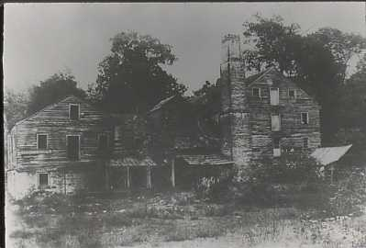
Distillery at Rock Bridge

Early Center of Commerce
Early settlers near Rock Bridge included the Reyburn family (circa 1810), Hickam (1830’s), and Saunders (1850’s). Though they never owned the land, brothers Thomas and Gilpin Tuttle built a mill near the Rock Bridge circa 1822 and added a distillery, general store and tanyard by 1827. Meanwhile, the Rock Bridge Valley area (about 800 acres) was purchased by Nathan and Peggy Glasgow in 1825 for $1.25/acre.
To meet the demands of a growing population, and to make their mill more accessible, in 1823 the Tuttles built a road that connected their mill to the road that ran south from Columbia past George Jewell’s farm to the town of Nashville along the Missouri River. Nashville was once an important river port town providing communication and transportation access to the Missouri River.
Increased steamboat traffic brought more settlers to the area. Nathan Glasgow sold parcels to John W. Kaiser and David S. Lamme. They established a paper mill in 1834 which operated for two years before closing. Lamme also hired Brightbery McAlester to build a mansion house on top of the ridge above the valley. In 1835, Lamme also opened a post office known as Rockbridge Mills, with himself as its first postmaster. The post office operated until 1844 when the land and supporting businesses were sold to James McConathy.
Like a rushing flood, in a few short years James McConathy completely re-shaped the economic operations in the valley. He added a swine herd of 200-400 hogs and increased distillery operations. By 1850 he owned the 2nd largest distillery in the state. That year he produced 5000 barrels of corn, wheat and rye whiskies worth $40,000, totaling 17 percent of the state’s whiskey.
McConathy had several advantages over his predecessors. He was wealthy enough to afford a larger workforce (about a dozen hired hands and 11 slaves). To take full advantage of the steamboat traffic (that had more than doubled since the 1830s), McConathy helped finance the $33,000, 12-mile long Providence Plank Road in the 1850’s. The road ran along present-day Hwy 163 from Columbia down Route K to the Missouri River at Providence. Heavy wagon traffic took its toll on the road which foreclosed after only two years and rapidly deteriorated over the next two decades.
The impact McConathy and other local industry had on the environment was tremendous. In 1847, McConathy was sued by his downstream neighbor William T. Smith. The charge was environmental pollution from hog slop and hog by-products spilling into Little Bonne Femme Creek, creating noxious smells and fish kills. The use of chemicals in the tanning operation, manure from local livestock and heavy timber cutting with the resulting stream siltation undoubtedly further degraded local water quality.
Locally, this rising tide of economic growth and resulting environmental decline was partially stemmed by the Civil War, the loss of slave labor, McConathy’s death in 1866, and a growing temperance movement.
Under the hands of the Emmitts in the 1870s and 1880s and then under the Heibels, the Rockbridge mills and distilleries operated intermittently until 1907 when Boone County passed a local option law outlawing the sale and production of whiskey (except for medicinal purposes). That same year, a suspicious fire destroyed the distillery. Without the distillery, economic operations, which had already considerably slowed, now collapsed. The Pierpont Store (then called A.R. Stephens General Merchandise) was moved to its current location at Hwy 163 and Rt. N along with the last remaining blacksmith shop in the area.
The land in the Rock Bridge area was eventually purchased by Dennis Ingram who, in 1922, converted part of the area into an amusement park, complete with rides, games and fairy floss (cotton candy). The amusement park did not succeed. In 1947, the mansion on top of the hill burned. In the 1960s, local citizens formed a coalition to raise money and turn the area into a park. They succeed in 1967 when it became Rock Bridge Memorial State Park.

Most of the Watershed is still rural, with development mostly occurring close to Columbia and Ashland, and some along the Highway 63 corridor. About 18% of the Watershed is in row-cropping, primarily east of Highway 63 where there is flatter land and deep soils. Pasture is about 42% of the area, spread throughout the watershed. Various forest types cover an additional 33%, most of it occurring west of Highway 63 in the areas with steeper terrain. Suburban and commercial development covers about 7% of the area.
About 88 % of the watershed is privately owned, and the remaining 12% publicly owned (University of Missouri-3.8%, Missouri Departments of Natural Resources and Conservation-6.5%, and City of Columbia-1.9% ).

Farming photo
Agricultural uses vary greatly. Most of the row cropping occurs east of highway 63 (except in a few creek floodplains), where the land is more conducive to tillage. Major crops include soybeans, corn, wheat, and milo. Native plant stock, perennial seed production, vegetables, fruit, and flowers are also found. The location of pasture and hay ground is located in more diverse places. The most prevalent livestock are beef cattle, horses, and swine; poultry, emus, and goats are also found in the watershed.
Boone County Horses
In a state that is 3rd in the nation in number of horses, Boone is the 10th ranked county. Horseback riding is popular in the watershed, with numerous trails on both private and public land. It also provides for substantial economic activity.
(Crane addition)
Outdoor recreation in the watershed is extremely varied, ranging from getting out in one’s backyard or neighborhood to visiting a public area. Hunting and fishing are popular on both public and private land. Over 35 miles of publicly-accessible trails are used for hiking, bird watching, hunting, mountain biking, horse back riding and cross-country skiing, in season. For example, the Devil’s Icebox Boardwalk in RBMSP has about 190,000 person-visits annually. Streams themselves provide numerous recreational opportunities, such as fishing, swimming, kayaking, and exploring stream critters. Caving is a popular activity as well, with people coming from around the world to participate in a wild cave tour of the Devil’s Icebox Cave; it is one of only a few guided wild cave tour programs offered to the public in the state and nation.
There are several important transportation routes through the Watershed. In addition to the internal road network, there are two routes that connect Columbia to other cities: Route WW connects to Fulton, and Highway 63 Connects Columbia, Ashland, Jefferson City and points to the north and south. The Columbia Regional Airport has commercial flights to St. Louis, in addition to servicing private planes.

The Watershed is an attractive place to live, in part because of its proximity to the major employment centers of Jefferson City and Columbia, and in part because of its natural beauty and opportunity for outdoor recreation. Since 2000, the Cities of Ashland and Columbia have each annexed approximately 2 square miles in the Watershed. There are numerous new subdivisions of moderate urban density recently constructed, under construction, and in the planning stages. These are concentrated in the northeast part of Ashland, along the Route K corridor south of Columbia, and north of Gans Road. There are also numerous 5-10 acre plots with new houses scattered throughout the watershed.
Commercial development is minimal in the watershed, except for in a few pockets. These are concentrated around the intersection of Highways 63 and 163, and that of Highway 63 and Route AC. Commercial activities include a lumber yard, a few gas stations, and several other retail operations.
Two major pipelines pass through the watershed sharing the same corridor. Entering the watershed from the Missouri River side of the watershed, passing through Rock Bridge Memorial State Park, they terminate at a major tank farm on the west side of Highway 63. This location straddles the Bonne Femme and Little Bonne Femme watershed divide. Other pipelines leave the tank farm continuing through the eastern portion of the watershed. Products carried in the pipelines are petroleum products, liquid fertilizer and natural gas. The pipeline tank farm is a distribution terminal for filling tanker trucks. The storage facilities at this location is capable of storing large amounts of a variety of products, none of which would be neutral or beneficial to the environment or the waters of the watershed.

Demographics

During the 1990s, population in the watershed is estimated to have increased by 40%, and existing data indicate it will continue to grow. The Columbia Area Transportation Study Organization (CATSO) estimates population will continue growing at a rate of 2% annually through 2030 for Boone County, giving a total of 245,356 people in the entire county (Table 1). Growth in dwelling units for both the entire county and the watershed is detailed in Table 2. Table 3 has rough estimates on population growth over the last 5 years. Although these estimates are not precise, they are included to give an indication of how much the area’s population is growing. It is interesting to note that population in the watershed is growing considerably faster than that of the entire county for each of the last 5 years and the 1990s. In contrast, new dwelling units/ mi.² was always lower for the watershed when compared to the entire county.

Construction photo

Table 1. Census figures for the past 100 years for Columbia and Boone County, including the average growth rate on a decadal scale.
 | Columbia |  | Boone County
year | population | Growth rate¹ | population | Growth rate¹
1900 | 5651 |  | 28642
1910 | 9662 | 5.5% | 30533 | 0.6%
1920 | 10392 | 0.7% | 29672 | -0.3%
1930 | 14967 | 3.7% | 30995 | 0.4%
1940 | 18399 | 2.1% | 34991 | 1.2%
1950 | 31974 | 5.7% | 48432 | 3.3%
1960 | 36650 | 1.4% | 55202 | 1.3%
1970 | 58512 | 4.8% | 80911 | 3.9%
1980 | 62061 | 0.6% | 100376 | 2.2%
1990 | 69101 | 1.1% | 112379 | 1.1%
2000 | 84531 | 2.0% | 135454 | 1.9%
2030² | 153116 |  | 245356

1. average annual growth rate for the previous decade
2. Projected annual growth rate assumed to be 2.0%.

Table 2. New dwelling units in Bonne Femme Watershed Project (BFWP) and entire Boone County (including all incorporated areas).
 | Single Family |  | Duplex |  | 3 or 4 Family |  | 5+ Family |  | Total New Dwelling Units |  | New dwelling units/mi.²
year | BF | BC | BF | BC | BF | BC | BF | BC | BF | BC | BF | BC
2000 | 72 | 969 | 0 | 84 | 27 | 8 | 0 | 276 | 99 | 1337 | 1.1 | 2.0
2001 | 60 | 1085 | 0 | 54 | 12 | 36 | 0 | 60 | 72 | 1235 | .8 | 1.8
2002 | 172 | 1158 | 0 | 88 | 27 | 49 | 0 | 516 | 199 | 1811 | 2.1 | 2.6
2003 | 172 | 1359 | 6 | 292 | 9 | 16 | 0 | 509 | 187 | 2176 | 2.0 | 3.2
2004 | 116 | 1586 | 20 | 386 | 3 | 16 | 0 | 628 | 139 | 2616 | 1.5 | 3.8

BF=Bonne Femme Watershed; BC=Boone County

Table 3. Rough population estimates based on new dwelling units, using the 2000 U.S. census as the starting point.
 | Total New Dwelling Units |  | New Population¹ |  | Total Population |  | Annual Population Growth Rate
year | BF | BC | BF | BC | BF | BC | BF | BC
2000 | 99 | 1337 | 198 | 2,674 | 4,698 | 138,128 | 4.4% | 2.0%
2001 | 72 | 1235 | 144 | 2,470 | 4,842 | 140,598 | 3.1% | 1.8%
2002 | 199 | 1811 | 396 | 3,622 | 5,240 | 144,220 | 8.2% | 2.6%
2003 | 187 | 2176 | 374 | 4,352 | 5,614 | 148,572 | 7.1% | 3.0%
2004 | 139 | 2616 | 278 | 5,232 | 5,892 | 153,804 | 5.0% | 3.5%

1. Assumes 2 new people/new dwelling unit.

1.d. Economics
Assessing economic activity in the watershed is a challenging process. This is due in part to the fact that if economic data are collected for various sectors of the economy, they are not collected on a watershed basis. In addition, some sectors do not have good economic data collected, and various economic activities occur completely outside of the market economy.
Farming is a business that is widespread throughout the watershed, and occupies the greatest area of all land uses. If we assume that the proportion of the county’s farming activity occurring in the watershed is proportional to its area (14% of the county), we derive the following annual numbers: $2.8 million dollars from crop production, $2.2 million from livestock. In addition, government payments to farmers in the watershed were $260,000 annually, with average payments for those farms receiving them were $4,145 (NASS, 2002).
The value of construction activities in the watershed can be evaluated using data from both Boone County and City of Columbia building permits. These permits ask the permit-holder to estimate the value of construction, whether it be new construction or an alteration to an existing building. For 2004, the total value for construction in the watershed was estimated to be $18.5 million.
Retail activity is not very high in the watershed currently, although that is slated to change with the addition of retail space at the Bristol Lakes development. The retail is primarily located in Ashland and along the Highway 63 corridor.
The tourist and recreational activities of the watershed mostly do not have economic activities associated directly with them, although their presence encourages economic activity. For example, somebody who goes caving is going to need to purchase specialized equipment, and may be coming from outside the area to, thereby bringing dollars into the local economy. Other activities such as hunting, fishing, horse-back riding, etc. will have similar positive economic impacts.
The environment itself provides important ecological services that are usually outside of traditional economic analyses, but are included here to help give perspective to their importance. They are difficult to quantify because they exist outside of the market economy; yet, without their existence, we would have to pay for expensive alternatives. These ecological services are diverse, including such things as nutrient cycling, erosion and flood control, pollination, food production, raw materials, and recreation. It is helpful to look at an example of a specific ecological service, such as food production: this service includes the habitat for game and fish and the soil resource which serves as the ecological basis for food production. Costanza et al. (1997) developed a methodology for valuing these ecosystem services based on land cover/land use. Following this methodology, the watershed provides approximately $33.5 million in annual ecological services.

1.e. Plan Overview
To be completed when the plan is assembled.

